VERIFICATION OF WSL INSTALLATION:
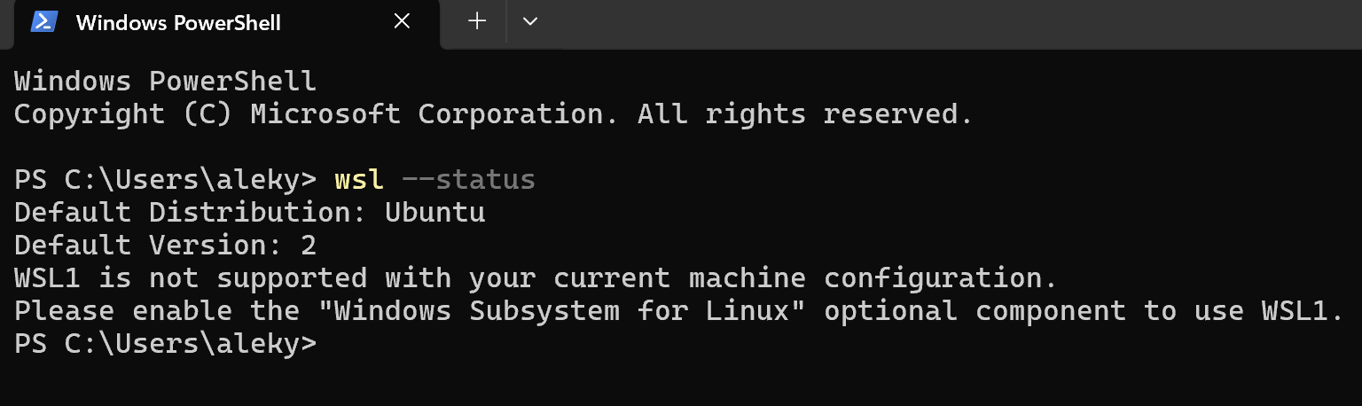
VERIFICATION OF GCC VERSION:
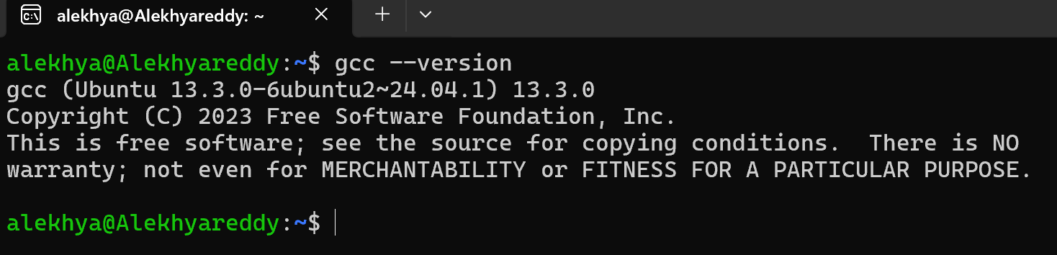
GCC PROGRAM:
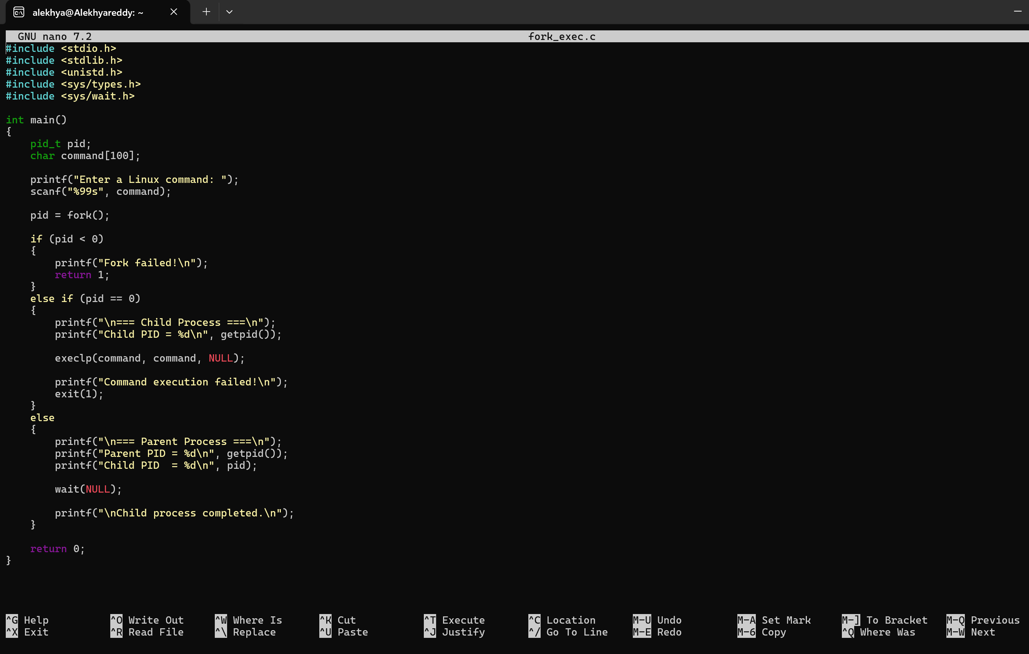

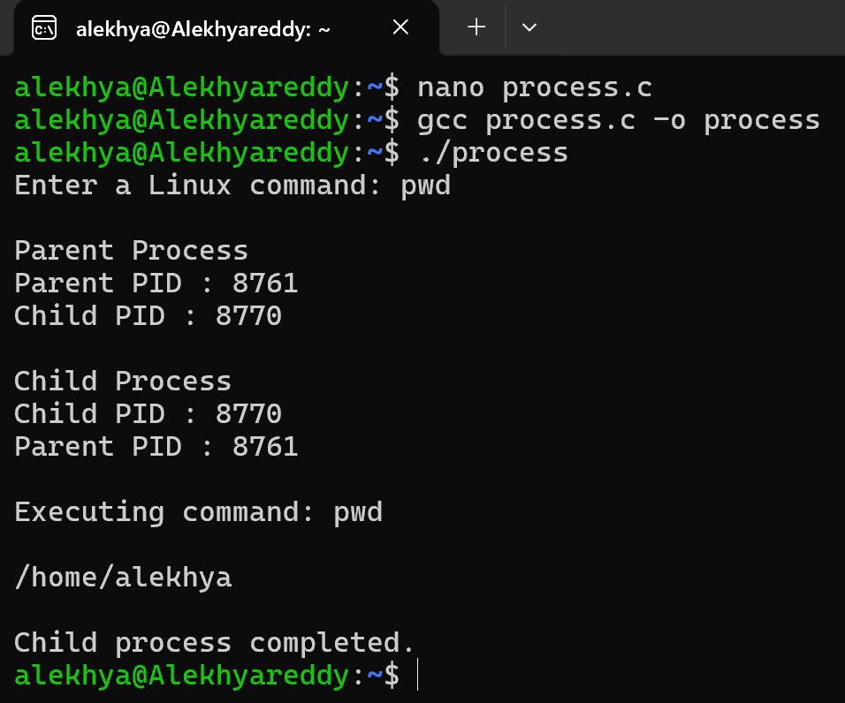
SIMPLE COMMANDS:
